Project demonstration

Enforcing Mandatory Fields Using UI Policies and
Migrating Changes with Update Sets demo

https://drive.google.com/file/d/1Ca57xJcRU-Kba8-5Obleot-VHKOCRYq_/view?usp=drivesdk

DEMONSTRATION STEPS
1. Login to ServiceNow Instance
First, log in to the ServiceNow platform using valid administrator credentials. After logging in, the dashboard of the ServiceNow instance appears where different modules and configurations can be accessed.

2. Open the Incident Module
Navigate to the Incident module in the ServiceNow platform. The Incident form allows users to create and manage IT service incidents. This form will be used to demonstrate how mandatory fields are enforced using UI Policies.

3. Create a UI Policy
Navigate to the UI Policies module in ServiceNow and create a new UI Policy for the Incident table. The UI Policy is configured to control the behavior of form fields such as making them mandatory.

4. Configure UI Policy Actions
In the UI Policy Actions section, select the fields that need to be controlled by the policy. Fields such as Short Description, Category, and Priority can be configured as mandatory fields.

5. Test the UI Policy
Open the Incident form and try to submit a record without filling the required fields. The system will prevent submission and display validation messages indicating that mandatory fields must be completed.

6. Fill Required Information
Enter the necessary information in the mandatory fields. After filling all required fields, the user can successfully submit the incident record.

7. Create an Update Set
Navigate to the Update Sets module and create a new Update Set. This Update Set will capture the configuration changes made in the system, including the UI Policy created earlier.

8. Capture Configuration Changes
The system automatically records the UI Policy configuration in the active Update Set. This allows administrators to track configuration changes made during development.

9. Migrate the Update Set
Export the Update Set from the development instance and import it into another instance such as testing or production. This ensures that the same configuration changes are applied across multiple ServiceNow environments.

RESULT
The demonstration confirms that the system successfully enforces mandatory fields in the ServiceNow Incident form using UI Policies. Users are required to provide necessary information before submitting records.
Additionally, Update Sets capture configuration changes and allow administrators to migrate those changes between different ServiceNow instances. This improves consistency and simplifies configuration management.
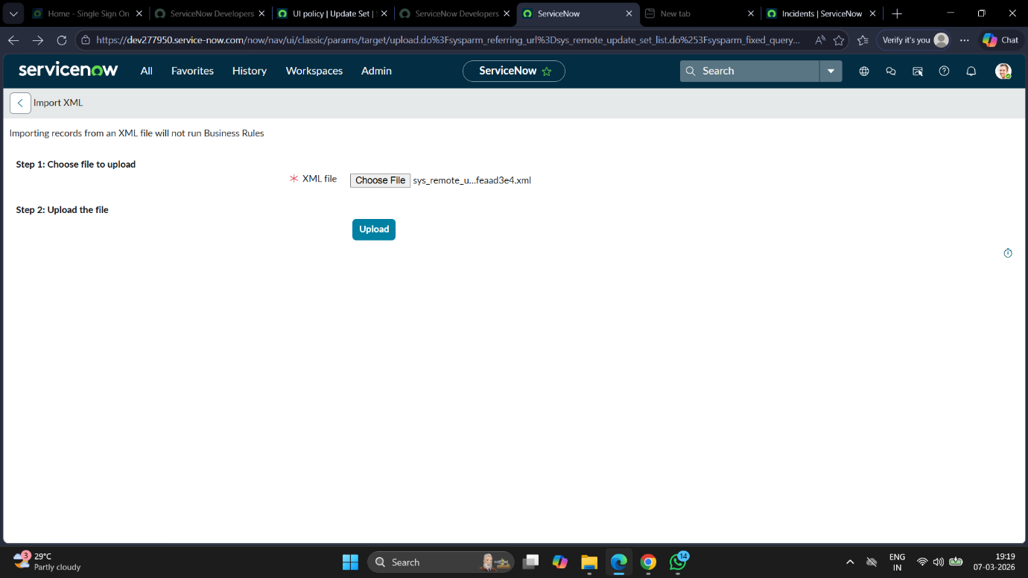
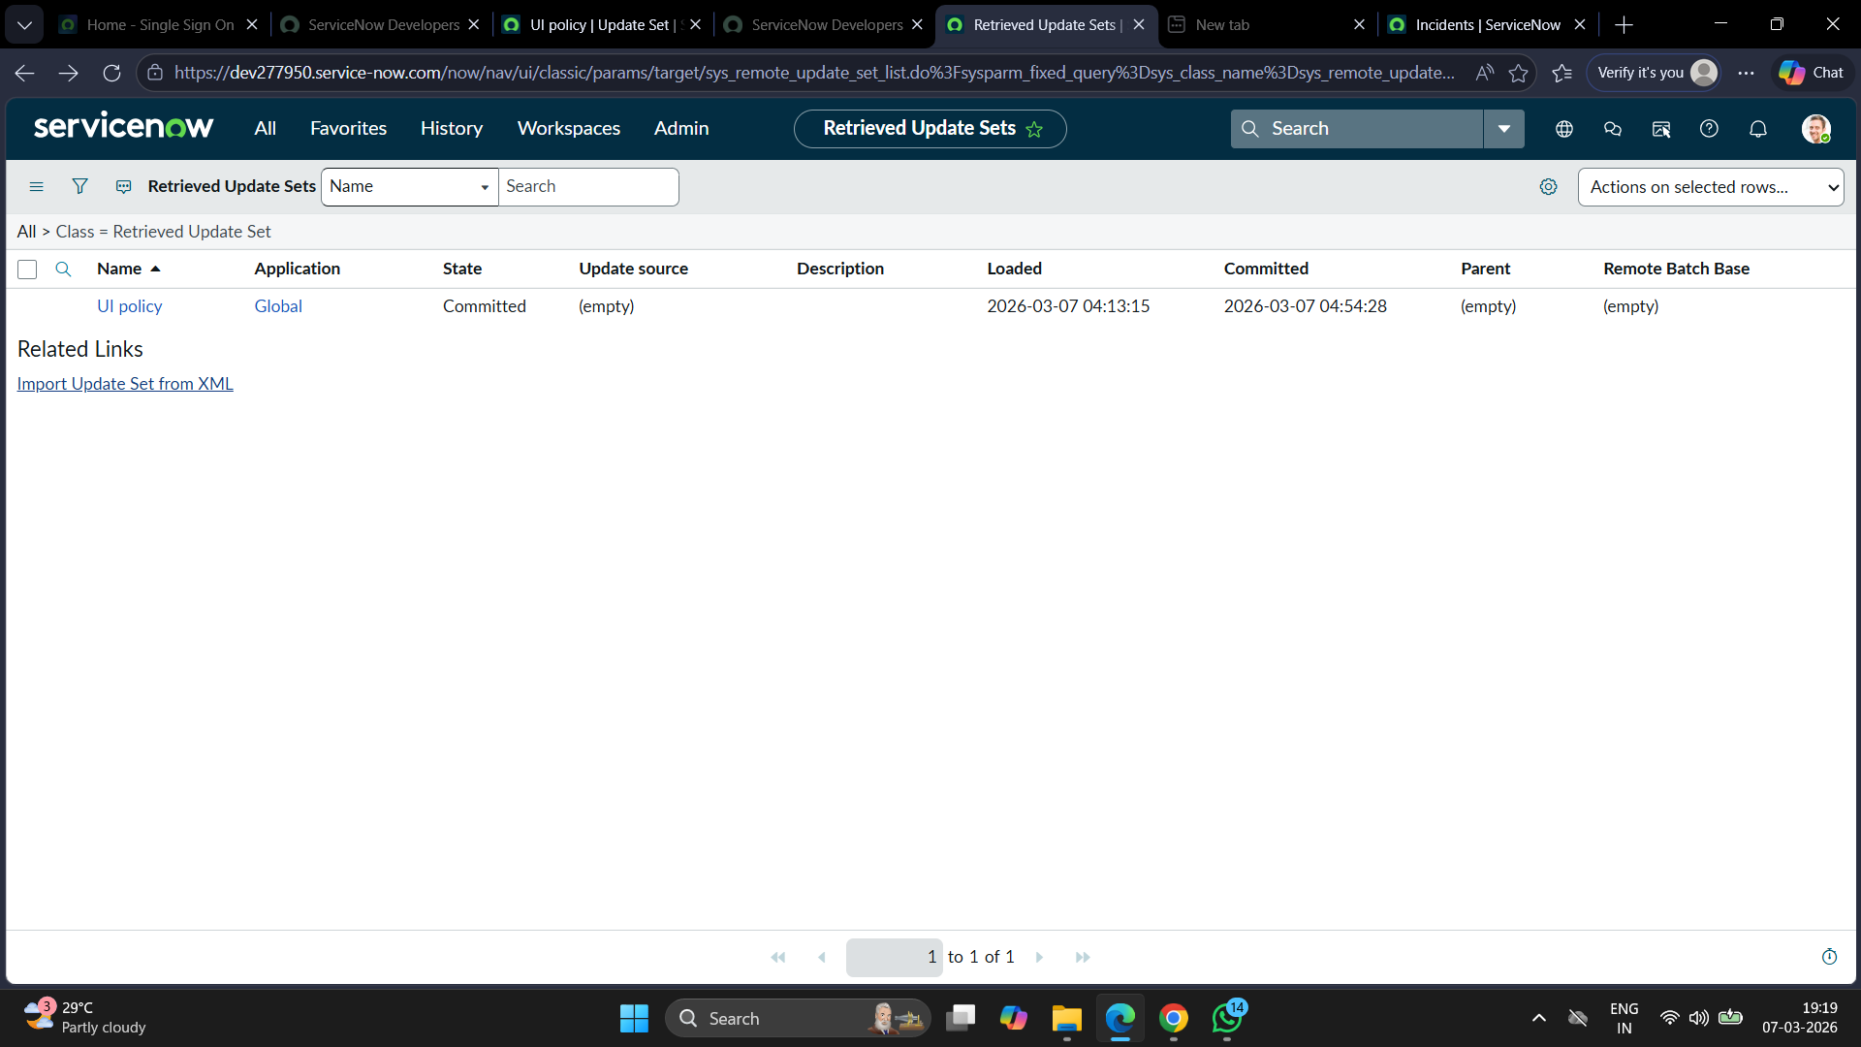

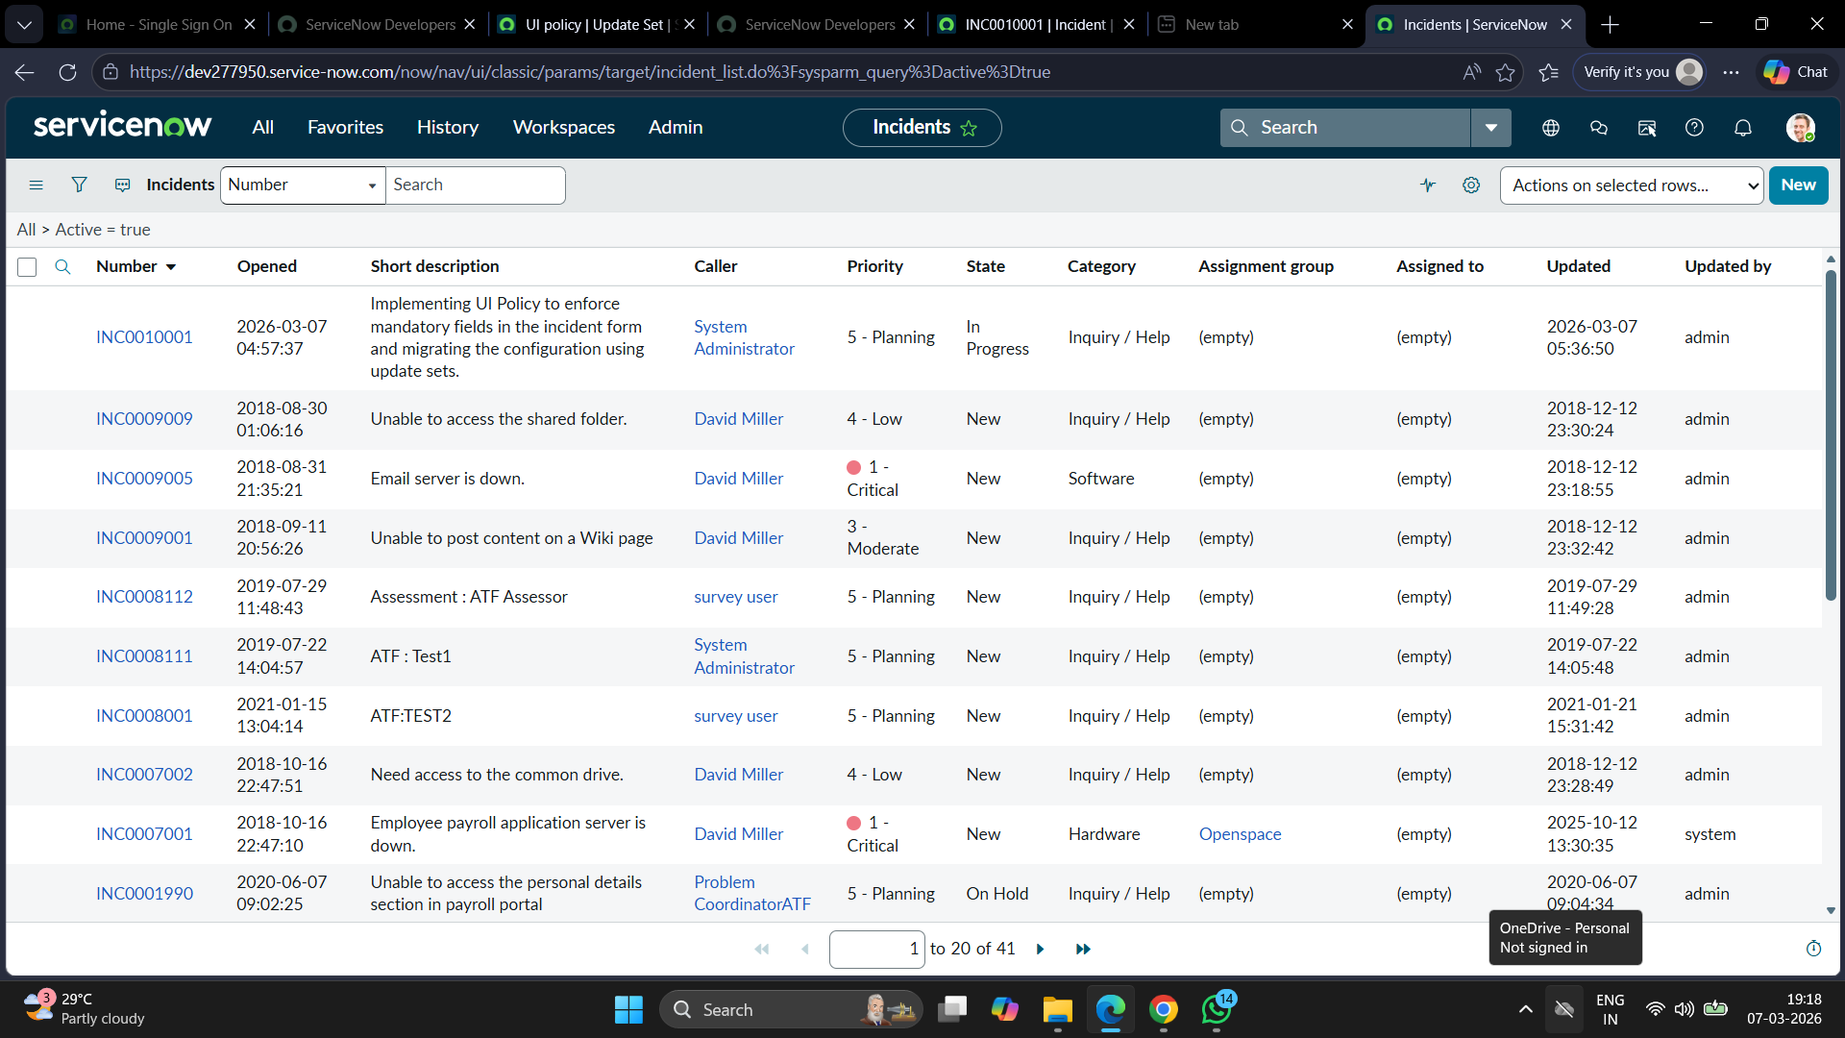

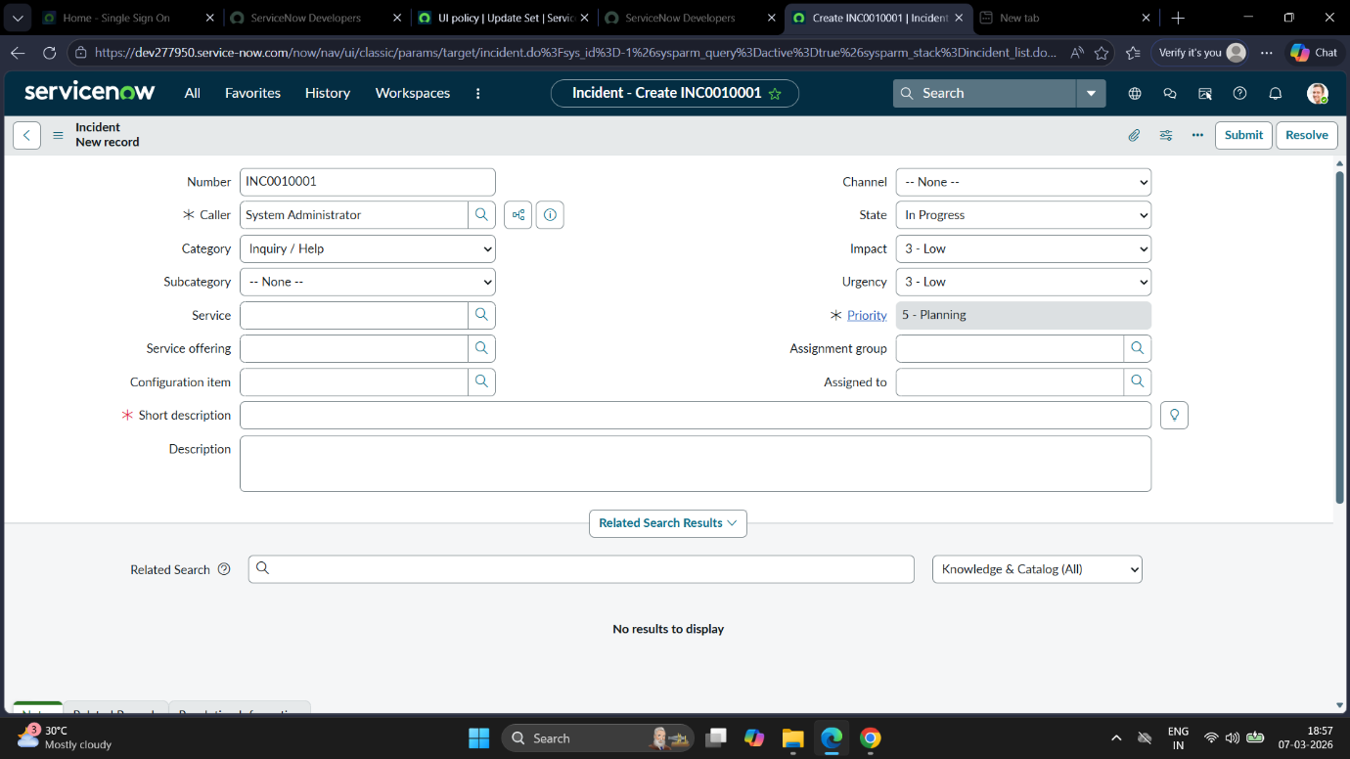

CONCLUSION

This project demonstrates the practical implementation of enforcing mandatory fields using UI Policies in ServiceNow. By ensuring that required fields are completed before record submission, the system improves data accuracy and prevents incomplete records.
Furthermore, Update Sets provide an efficient method for migrating configuration changes between development, testing, and production environments. This approach reduces manual effort and ensures consistency across the ServiceNow platform.

